1st Psalm
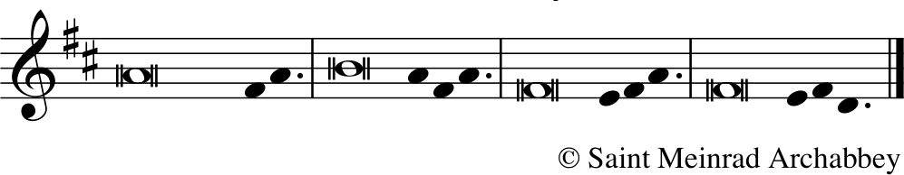
4th Stanza only:

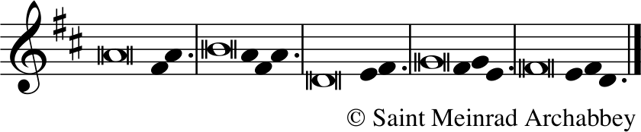
(1) Lord, send out your Spirit,
(4) and renew the face of the earth.
Bless the LORD, O my soul!
O LORD, my God, you are great indeed!
You are clothed with majesty and glory,
robed in light as with a cloak.

(1) Lord, send out your Spirit,
(4) and renew the face of the earth.
You fixed the earth upon its foundation,
not to be moved forever;
with the ocean, as with a garment, you covered it;
above the mountains the waters stood.
(1) Lord, send out your Spirit,
(4) and renew the face of the earth.
You send forth springs into the watercourses
that wind among the mountains.
Beside them the birds of heaven dwell;
from among the branches they send forth their song.
(1) Lord, send out your Spirit,
(4) and renew the face of the earth.
[Use 2nd Psalm Tones]
You water the mountains from your palace;
the earth is replete with the fruit of your works.
You raise grass for the cattle,
and vegetation for man's use,
Producing bread from the earth.
(1) Lord, send out your Spirit,
(4) and renew the face of the earth.
How manifold are your works, O LORD!
In wisdom you have wrought them all—
the earth is full of your creatures.
Bless the LORD, O my soul!
(1) Lord, send out your Spirit,
(4) and renew the face of the earth.

2nd Psalm

(1) You are my inheritance, Oh Lord.
O LORD, my allotted portion and my cup,
you it is who hold fast my lot.
I set the LORD ever before me;
with him at my right hand I shall not be disturbed.

(1) You are my inheritance, Oh Lord.
Therefore my heart is glad and my soul rejoices,
my body, too, abides in confidence;
because you will not abandon my soul to the netherworld,
nor will you suffer your faithful one to undergo corruption.

(1) You are my inheritance, Oh Lord.
(1)You will show me the path to life,
(2)fullness of joys in your presence,
(4)the delights at your right hand forever.

(1) You are my inheritance, Oh Lord.

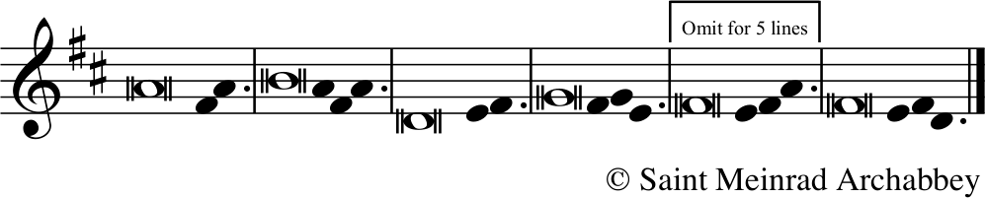
3rd Psalm

(1) Let us sing to the Lord;
(6) he has covered himself in glory.
I will sing to the LORD, for he is gloriously triumphant;
horse and chariot he has cast into the sea.
My strength and my courage is the LORD,
and he has been my savior.
He is my God, I praise him;
the God of my father, I extol him.

(1) Let us sing to the Lord;
(6) he has covered himself in glory.

The LORD is a warrior,
LORD is his name!
Pharaoh's chariots and army he hurled into the sea;
the elite of his officers were submerged in the Red Sea.
(1) Let us sing to the Lord;
(6) he has covered himself in glory.

The flood waters covered them,
they sank into the depths like a stone.
Your right hand, O LORD, magnificent in power,
your right hand, O LORD, has shattered the enemy.

(1) Let us sing to the Lord;
(6) he has covered himself in glory.
You brought in the people you redeemed
and planted them on the mountain of your inheritance --
the place where you made your seat, O LORD,
the sanctuary, LORD, which your hands established.
The LORD shall reign forever and ever.
(1) Let us sing to the Lord;
(6) he has covered himself in glory.

4th Psalm

(1)I will praise you, Lord,
(4) for you have rescued me.

I will extol you, O LORD, for you drew me clear
and did not let my enemies rejoice over me.
O LORD, you brought me up from the netherworld;
you preserved me from among those going down into the pit.

(1)I will praise you, Lord,
(4) for you have rescued me.
Sing praise to the LORD, you his faithful ones,
and give thanks to his holy name.
For his anger lasts but a moment;
a lifetime, his good will.
At nightfall, weeping enters in,
but with the dawn, rejoicing.
(1)I will praise you, Lord,
(4) for you have rescued me.
Hear, O LORD, and have pity on me;
O LORD, be my helper.
You changed my mourning into dancing;
O LORD, my God, forever will I give you thanks.
(1)I will praise you, Lord,
(4) for you have rescued me.

Psalm 5

(1)You will draw water joyfully
(4) from the springs of salvation.
God indeed is my savior;
I am confident and unafraid.
My strength and my courage is the LORD,
and he has been my savior.
With joy you will draw water
at the fountain of salvation.

(1)You will draw water joyfully
(4) from the springs of salvation.
(1)Give thanks to the LORD, acclaim his name;
(2)among the nations make known his deeds,
(4)proclaim how exalted is his name.
(1)You will draw water joyfully
(4) from the springs of salvation.

Sing praise to the LORD for his glorious achievement;
let this be known throughout all the earth.
Shout with exultation, O city of Zion,
for great in your midst
is the Holy One of Israel!
(1)You will draw water joyfully
(4) from the springs of salvation.

Psalm 6

(1) Lord, you have the words
(4) of everlasting life.
The law of the LORD is perfect,
refreshing the soul;
the decree of the LORD is trustworthy,
giving wisdom to the simple.
(1) Lord, you have the words
(4) of everlasting life.
The precepts of the LORD are right,
rejoicing the heart;
the command of the LORD is clear,
enlightening the eye.
(1) Lord, you have the words
(4) of everlasting life.
The fear of the LORD is pure,
enduring forever;
the ordinances of the LORD are true,
all of them just.
(1) Lord, you have the words
(4) of everlasting life.
They are more precious than gold,
than a heap of purest gold;
sweeter also than syrup
or honey from the comb.
(1) Lord, you have the words
(4) of everlasting life.

Psalm 7 (When Baptism is Celebrated)

(1)Like a deer that longs for running streams,
(2)my soul longs for you, my God.
Athirst is my soul for God, the living God.
When shall I go and behold the face of God?

(1)Like a deer that longs for running streams,
(2)my soul longs for you, my God.
I went with the throng
and led them in procession to the house of God,
Amid loud cries of joy and thanksgiving,
with the multitude keeping festival.
(1)Like a deer that longs for running streams,
(2)my soul longs for you, my God.
Send forth your light and your fidelity;
they shall lead me on
And bring me to your holy mountain,
to your dwelling-place.
(1)Like a deer that longs for running streams,
(2)my soul longs for you, my God.
Then will I go in to the altar of God,
the God of my gladness and joy;
then will I give you thanks upon the harp,
O God, my God!
(1)Like a deer that longs for running streams,
(2)my soul longs for you, my God.

Psalm 7 (No Baptism)

(1) Create a clean heart
(4) in me, O God.
A clean heart create for me, O God,
and a steadfast spirit renew within me.
Cast me not out from your presence,
and your Holy Spirit take not from me.
(1) Create a clean heart
(4) in me, O God.
Give me back the joy of your salvation,
and a willing spirit sustain in me.
I will teach transgressors your ways,
and sinners shall return to you.
(1) Create a clean heart
(4) in me, O God.
For you are not pleased with sacrifices;
should I offer a holocaust, you would not accept it.
My sacrifice, O God, is a contrite spirit;
a heart contrite and humbled, O God, you will not spurn.
(1) Create a clean heart
(4) in me, O God.

